PS1Q3

Xiang Li

2024-01-23

library("quantmod")

##(a) Compile quarterly data for the U.S. real gross private domestic investment (DI) from 1947Q1 to 2023Q4.

getSymbols(Symbols ="GPDI",src = "FRED", from = '1947/01/01')

## [1] "GPDI"

qua_di <- as.matrix(GPDI[,1])  
qua_di_date = as.Date(row.names(qua_di))  
n_obs_qua_di = length(qua_di_date)

##(b) Compute growth in quarterly DI (GDI), provide its summary statistics and plot the data.

di_return <- diff(qua_di)/qua_di[1:n_obs_qua_di-1,1]  
di_return_date = qua_di_date[2:n_obs_qua_di]  
n_obs_qua_return = length(di_return_date)  
plot(di_return, type = "l", col = "darkblue", main = "Growth in Quarterly GDI", ylab = "GDI Growth")

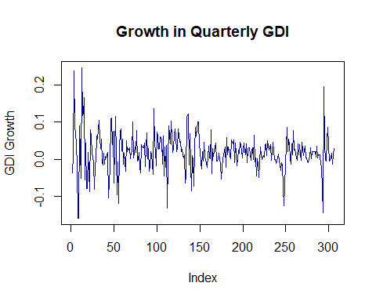

##(c) Compute and plot empirical autocorrelation function. Given the plot, do you expect any time-series correlation among the observations? Explain why?

acf(di_return,lag=round(n_obs_qua_return^(1/3)))

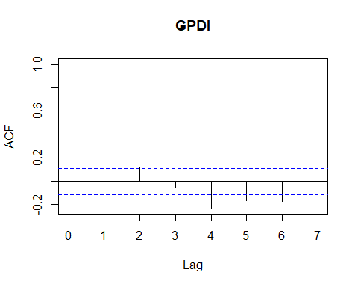

ACF=acf(di_return,lag=round(n_obs_qua_return^(1/3)), plot = FALSE)  
ACF$acf

## , , 1  
##   
## [,1]  
## [1,] 1.00000000  
## [2,] 0.18230712  
## [3,] 0.11675470  
## [4,] -0.04992628  
## [5,] -0.22861728  
## [6,] -0.16254377  
## [7,] -0.17190977  
## [8,] -0.05641716

Yes I do expect some time-series correlation among the observations. Because there are some lags where the bars extend beyond the dotted lines.

##(d) Set the maximum number of lags to the integer closest to the number of observations to the power one-third. Perform a test for joint autocorrelation in GDI and report your result. Does your finding consistent with that of Part 3c? Explain why?

t_ratio <- ACF$acf[2]*sqrt(n_obs_qua_return)   
t_ratio

## [1] 3.189072

Box.test(di_return, lag = round(n_obs_qua_return^(1/3)), type = "Ljung-Box")

##   
## Box-Ljung test  
##   
## data: di_return  
## X-squared = 50.143, df = 7, p-value = 1.354e-08

Box.test(di_return, lag = round(n_obs_qua_return^(1/3)), type = "Box-Pierce")

##   
## Box-Pierce test  
##   
## data: di_return  
## X-squared = 49.199, df = 7, p-value = 2.074e-08

##(e) Consider an AR(1) model and compute the theoretical autocorrelation function. Compare your findings with that of Part 3c.

lag_di_return = rbind(NA, as.matrix(di_return[1:(n_obs_qua_return-1),1]))  
intercept = matrix(1,n_obs_qua_return)  
X = cbind(intercept,lag_di_return)  
y = di_return  
reg_result = ols(X[2:n_obs_qua_return,],as.matrix(y[2:n_obs_qua_return,1]))  
1 - sum(reg_result$u_hat^2)/sum(y^2)

## [1] 0.1381177

beta_hat = reg_result$beta_hat  
beta_hat

## [,1]  
## [1,] 0.01449087  
## [2,] 0.18233574

var_beta_hat = reg_result$var_beta_hat  
test_result = t_test(beta_hat,var_beta_hat)  
test_result$t_stat

## [,1]  
## [1,] 4.769901  
## [2,] 3.244819

test_result$p_value

## [,1]  
## [1,] 1.843163e-06  
## [2,] 1.175253e-03

ar_coeff <- as.numeric(beta_hat[2])  
ma_coeff <- 0  
TACF <- ARMAacf(ar_coeff, ma_coeff, lag.max = round(n_obs_qua_return^(1/3)))   
plot(c(0:round(n_obs_qua_return^(1/3))),ACF$acf,type='l',xlab='Lag',ylab='ACF',ylim=c(-0.1,1))  
lines(0:round(n_obs_qua_return^(1/3)),TACF,lty=2)  
grid(nx = 4, ny = 4)

